Project Requirements Document

# 

**Overview 3**

**Functional Requirements 4**

User Management 4

Core Features 4

Additional Features 4

Automated Route Planning 5

Core Features 5

Addtional Features 5

Social & Gamification 5

Core Features 5

Additional Features 6

Training and Wellness 7

Core Features 7

Additional Features 7

Accessibility 7

**Non-Functional Requirements 8**

Performance 8

Scalability 8

Reliability 8

Security 8

Usability 8

Compliance 9

Maintainability 9

Backup and Recovery 9

**Questions for the Stakeholders 10**

**Diagrams 12**

Use Case 12

Class Diagram 12

Personas 13

# 

# Overview

This is a project requirements document for a route generator web application. This document will give a complete analysis of all the requirements required in order to complete the project. The purpose of the route generator application is to make running / cycling more engaging.

# Functional Requirements

A good idea could be to implement 2 versions of the web app, one of a more advanced version and another more simple. Also a mobile application to go along side the web application has been considered and will be discussed further with the stakeholders.

## User Management

### Core Features

* The user should be able to create accounts, log in and log out securely.
* Provide account recovery system.
* Provide secure data integration complying for privacy regulations and security protocols.
* The user should be able to manage account including preferences like route length, terrain type, preferred locations and preferred time of day to run.
* Provide features to allow user feedback and potential improvements.
* The screen should be crossplatform and integrate features to adjust the screen size for all devices.
* The website will integrate testing to ensure validity and robustness.

### Additional Features

* Social media login options through google, facebook, linkedIn…
* Allow users to update their fitness goals over time.
* Include options for users to save routes and revisit them later.
* Provide analytical insight displayed through graphs and other data visualisation methods for a summery of weekly and monthly activity. This can be metrics like distance, pace and time.
* Localise region.
* Allow users to customize their profiles with personal achievements, favorite routes, and motivational quotes or images.

## Automated Route Planning

### Core Features

* Integrate a mapping API (Google Maps) to generate running routes based on user-defined parameters like distance, location and terrain.
* Enable the application to generate new routes daily or as requested by the user.
* Utilise “hot spots” that indicate destinations that are preferable to go to.
* The route planner should include weather updates for tomorrow or todays run based of preferred time of day to run.
* Offer multiple runs and allows the user to select one.

### Addtional Features

* Include options for selecting different types of routes like scenic, high elevation or bike routes.
* Offer routes that can be switched between running, walking, cycling, or hiking modes, each with tailored suggestions and considerations.
* Display “hot spots” using a coloured heat map allowing users to see where they have indicated to go.
* Enable hot spot data to either be shared or kept private to everyone allowing others to post good spots to visit.
* The weather update should suggest training indoors and alternative routes based off weather conditions.
* Allows user to customise by adding avoiding spots like roads and areas.
* Allows custom waypoints.
* Downloadable routes for offline access.
* Provide alternative routes for closed roads and bad air quality areas based off external metrics.
* Run time estimations based on previous examples

## Social & Gamification

### Core Features

* A leaderboard feature should be implemented in order to rank themselves given metrics like:
  + Distance covered
  + Time spent running
  + Routes completed
  + Quickest 5k time
  + Quickest 10k time

### Additional Features

* Allow social features like sharing routes, achievements and progression with others.
* Allow challenges and competitions to be joined and created by users.
* Introduce badges, rewards and milestones for users.
* Allows users to compete in a run off during a run where another runner wanting to compete is matched based off best / average times and an online race commences.
* Allows sharing of badges and metrics.
* Provide a notification system to update local events / challenges.
* Allows a new mode that allows you to discover popular runs or one off routes that people have uploaded that are extra scenic / special
* Create groups or forums where you can discuss routes in local areas and challenge the group specifically.
* Create virtual events globally where everyone globally can join and compete.
* Introduce themed challenges (e.g., "Run a Marathon Month") with unique rewards.
* Enable profile visibility settings, allowing users to choose what information to share publicly or keep private.
* Provide privacy settings allowing users to control who can view their routes, activities and profile details.
* Custom leaderboards such as by criteria like age or location.
* Integrate with local IRL running events, allowing users to sign up, see event-specific routes, and track their performance during the event.
* Allow users to team up with virtual running partners based on similar paces or goals, enabling them to run the same route or distance at the same time remotely. This could also be integrated as a rival.
* Reset the leaderboards every so often and create seasons with inclusion of ranks where you are catagorised in ranks based off last seasons results and rank. (Could use ELO)

## Training and Wellness

### Core Features

* Training plan offered to assist users on reaching goals. For example training for a race, improving endurance or losing weight.
* Utilise user feedback and user progression to tailor the training plan to the user over time.
* The application should suggest to not go out on days where the weather is too extreme.

### Additional Features

* Allows integration with wearable devices and health apps like apple health and google fit to track user activity.
* Provide feedback and adjustments based on health data.
* Provide nutrition and hydration advice based off training plans and route running activity.
* Suggest pre and post-run meals or snacks based of dietary preferences.
* Offer recovery tips and exercises to help prevent injuries and maintain user health.
* Include optional reminders for warm-up and cool-down exercises before and after runs.
* Incorporate mindfulness or relaxation exercises, particularly for users who might experience running as a stress-relief activity.
* Provide motivational content or guided audio runs to keep users engaged and positive during their workouts.
* Injury tracking and preventing, utilising previous injuries and trying to analyse the data off of that, suggesting rest periods and nutritional changes.

## Accessibility

* Language support.
* Implement features that enhance accessibility, such as text-to-speech for route instructions, customizable text sizes, and color contrast options.
* Ensure compatibility with assistive technologies to support users with disabilities.
* Allow users to customize the interface layout and colors to suit their preferences, including dark mode for low-light running conditions.

# Non-Functional Requirements

## Performance

* Response Time: The application should load maps, generate routes, and respond to user inputs within 2 seconds on average.
* The system should support at least 1,000 concurrent users without performance degradation.
* Real-time processing of user data, such as route updates and leaderboard changes, should be handled within 1 second.

## Scalability

* The application architecture should support seamless scaling to accommodate growing user numbers and new features.
* The system should be able to handle increased API requests, especially when scaling to support more users or additional features like data visualisation graphs.

## Reliability

* Implement robust error-handling mechanisms to gracefully manage and recover from unexpected issues, such as API failures or data processing errors.

## Security

* All user data, including personal details and route preferences, should be encrypted both in transit and at rest.
* Ensure compliance with privacy regulations like GDPR, including options for users to control their data and request deletion.

## Usability

* The application should feature an intuitive and user-friendly interface, ensuring ease of navigation across various devices.
* Comply with WCAG (Web Content Accessibility Guidelines) standards, offering features like screen reader compatibility and customizable font sizes.
* The application should function consistently across different browsers and devices, including mobile, tablet, and desktop.

## Compliance

* Ensure compliance with global data protection regulations, such as GDPR and CCPA, including proper data handling and user consent mechanisms.
* Adhere to accessibility standards (e.g., WCAG 2.1) to ensure the application is usable by individuals with disabilities.

## Maintainability

* Comprehensive documentation should be provided for developers, including API documentation, code comments, and user guides.

## Backup and Recovery

* Implement regular automated backups of all user data, route information, and system configurations to ensure data integrity.
* Ensure the system can recover quickly from failures or data corruption.

# Questions for the Stakeholders

Highest priority

Medium priority

Low priority

| **Questions** | **Answer** |
| --- | --- |
| Is it a good idea to do a mobile and web app? |  |
| How would i syncronise between web and mobile app? |  |
| What level of customisation is expected for the application to be considered complete? |  |
| Are there specific privacy concerns that you believe need to be addressed? |  |
| How should the application handle cases where users' preferences for terrain or location are unavailable? |  |
| Should the application offer manual route customization, allowing users to tweak automatically generated routes? |  |
| Are there specific weather data sources that should be used? |  |
| How frequently should leaderboards be updated (e.g., real-time, daily)? |  |
| What specific privacy setting should be applied to the data? |  |
| What level of customisation is expected for training plans? Should they adapt to user performance automatically? |  |
| What specific accessibility features are prioritised (e.g., voice commands, high contrast mode)? |  |
| What types of data visualisation are preferred for displaying user progress (e.g., charts, graphs, heat maps)? |  |
| Should users be able to customize or export these visualizations? |  |

# Diagrams

## Use Case

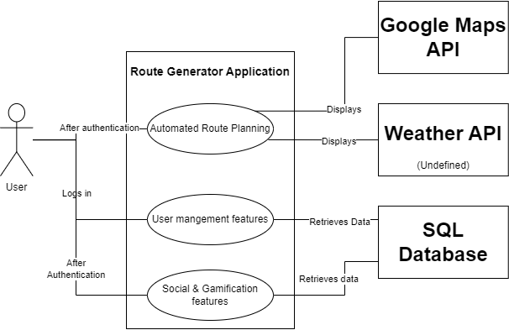

## Class Diagram

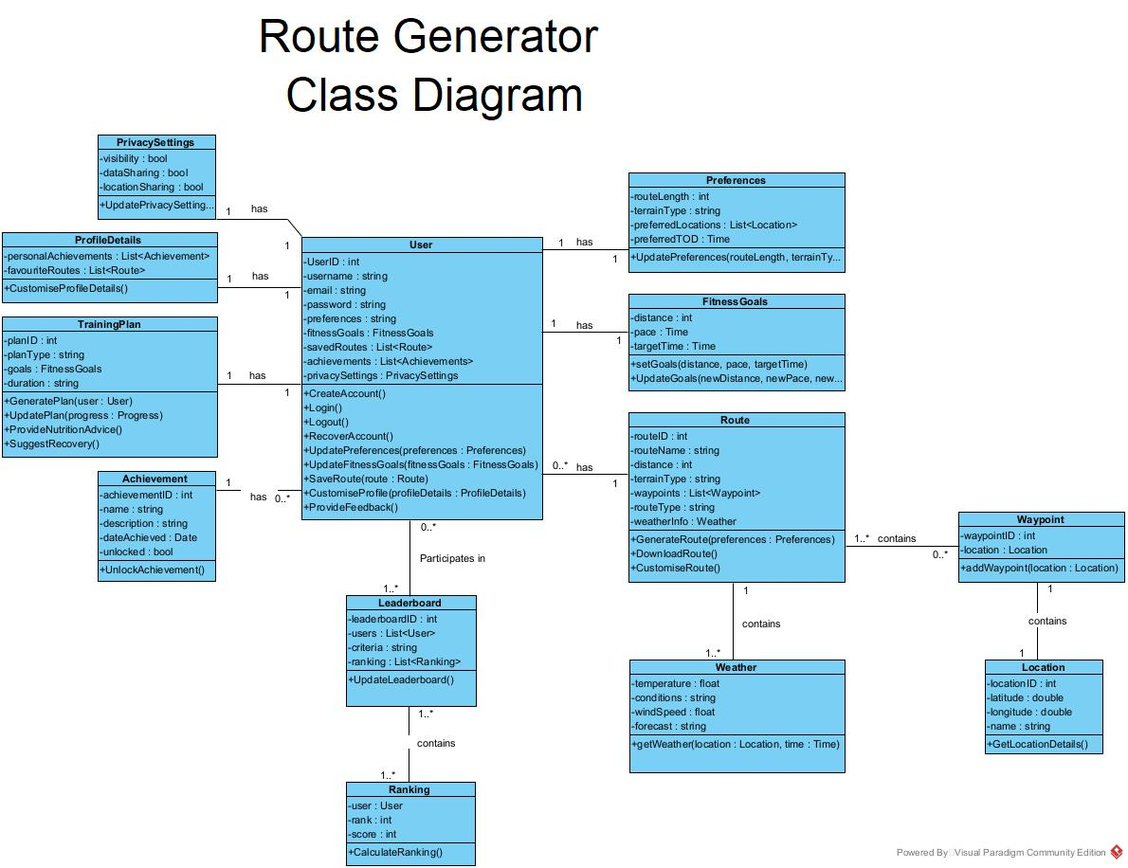

## 

## Personas